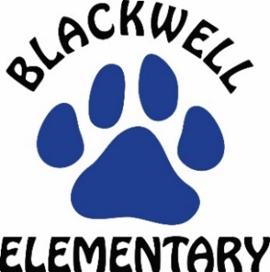
Believe*Excel*Succeed!
Digital Learning

Grade Level: Kindergarten-2nd
Digital Learning Expectations:
- The activities listed below are meant to be a guide. Please pick 2-3 activities per day depending on the needs of your child. The goal of these lessons is to have your child learning/maintaining the English language every day.
- If you have questions, please email me katherine.zurkuhlen@cobbk12.org
I am available Monday-Friday from 9:00-10:30.

Day | Activity
Monday | 1. Question of the Day: What makes you smile?  2. April Reading Challenge: Read at least 10-15 minutes using Raz-Kids https://raz-kids.com  3. Odd Sound Out: Students first listen to the three words parents say. Then it will be your turn to say the three words and listen to the first sound in each word as you say them. Which word did not begin with the first sound?  sit, sat, tap tub, bun, bus man, bat, mat  4. Rhyming: When two words have the same ending sound. Listen as I say these two words. Give me a thumbs up if you think they rhyme or a thumbs down if you think they do not rhyme.  pan, fan jet,net rug, mug map, man
Tuesday | 1. Question of the Day: What is your favorite color?  2. April Reading Challenge: Read at least 10-15 minutes using Raz-Kids https://raz-kids.com  3. Odd Sound Out: Students first listen to the three words parents say. Then it will be your turn to say the three words and listen to the first sound in each word as you say them. Which word did not begin with the first sound?  sun, bun, sock map, mail, fan tan, ran, top  4. Rhyming: When two words have the same ending sound. Listen as I say these two words. Give me a thumbs up if you think they rhyme or a thumbs down if you think they do not rhyme.  van, man cap, map hug, rug fun, fat
Wednesday | 1. Question of the Day: What is your favorite fruit?  2. April Reading Challenge: Read at least 10-15 minutes using Raz-Kids https://raz-kids.com  3. Odd Sound Out: Students first listen to the three words parents say. Then it will be your turn to say the three words and listen to the first sound in each word as you say them. Which word did not begin with the first sound?  ran, big, rig rat, bet, run tub, bun, bus  4. Rhyming: When two words have the same ending sound. Listen as I say these two words. Give me a thumbs up if you think they rhyme or a thumbs down if you think they do not rhyme.  pan, man mug, man rug, mug jet, net
Thursday | 1. Question of the Day: What is your favorite day of the week?  2. April Reading Challenge: Read at least 10-15 minutes using Raz-Kids https://raz-kids.com  3. Odd Sound Out: Students first listen to the three words parents say. Then it will be your turn to say the three words and listen to the first sound in each word as you say them. Which word did not begin with the first sound?  map, man, soap sit, sun, tap bug, rag, bag  4. Rhyming: When two words have the same ending sound. Listen as I say these two words. Give me a thumbs up if you think they rhyme or a thumbs down if you think they do not rhyme.  nap,net fan,man cap, map mug, hug
Friday | Beginning this week digital learning will occur Monday through Thursday. Please use today to catch up on any activities that you were not able to finish or to keep practicing on skills that you had trouble with.

